Q2

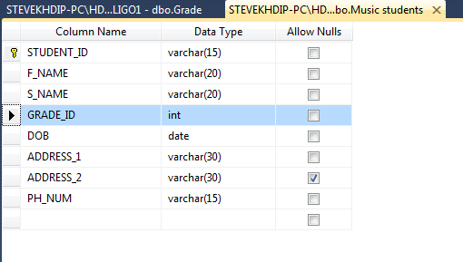

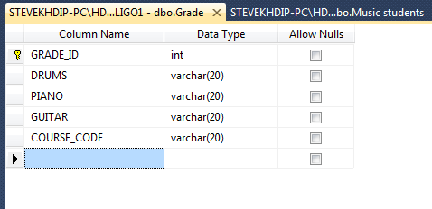
Q3

/****** Script for SelectTopNRows command from SSMS ******/
SELECT TOP 1000 [GRADE_ID]
,[DRUMS]
,[PIANO]
,[GUITAR]
,[COURSE_CODE]
FROM [ITSLIGO1].[dbo].[Grade]

/****** Script for SelectTopNRows command from SSMS ******/
SELECT TOP 1000 [STUDENT_ID]
,[F_NAME]
,[S_NAME]
,[GRADE_ID]
,[DOB]
,[ADDRESS_1]
,[ADDRESS_2]
,[P_NUM]
FROM [ITSLIGO1].[dbo].[Graded Students]

Q4

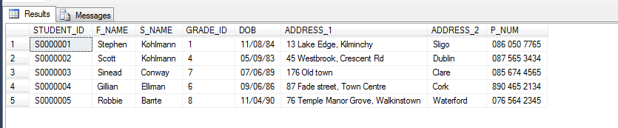

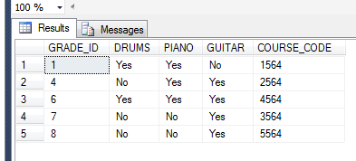
Q5

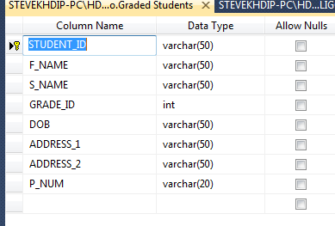

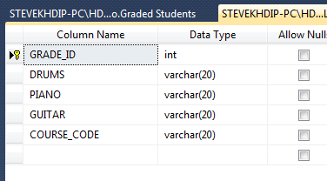

Q6

INSERT dbo.[Graded Students] (STUDENT_ID, F_NAME, S_NAME, GRADE_ID, DOB, ADDRESS_1, ADDRESS_2, P_NUM)

VALUES ('S0000006', 'Laura', 'Conway', 5, '12/7/1985', '17 Oak Crescent', 'Donegal', '085 654 7632'),
('S0000007', 'John', 'Swift', 7, '15/2/1987', '19 Oakfield, Lodge Road', 'Clare', '087 645 2341')

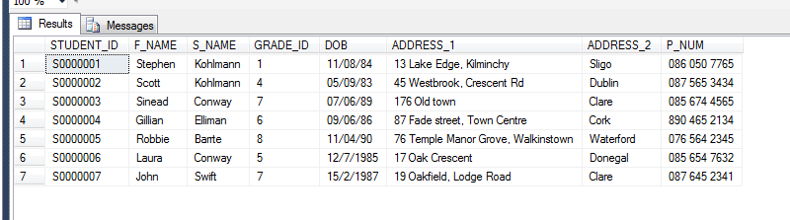

INSERT dbo.Grade (GRADE_ID, DRUMS, PIANO, GUITAR, COURSE_CODE)

VALUES ('9', 'Yes', 'Yes', 'No', '6889'),
('10', 'Yes', 'Yes', 'Yes', '7999')

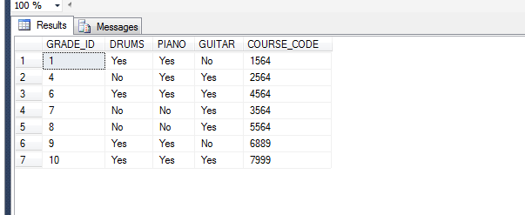

Q7

DELETE FROM dbo.[Graded Students]
WHERE STUDENT_ID > 'S0000005';

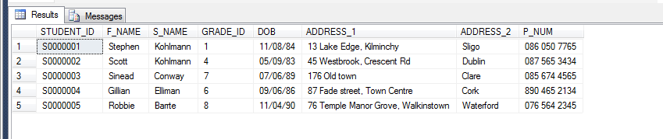

DELETE FROM dbo.Grade
WHERE GRADE_ID > 6;

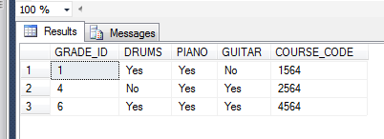
Q8

INSERT dbo.[Graded Students] (STUDENT_ID, F_NAME, S_NAME, GRADE_ID, DOB, ADDRESS_1, ADDRESS_2, P_NUM)
VALUES ('S0000001', 'Stephen', 'Kohlmann', 1, '11/08/84', '13 Lake Edge, Kilminchy', 'Sligo', '086 050 7765')

Msg 2627, Level 14, State 1, Line 1
Violation of PRIMARY KEY constraint 'PK_Graded Students'. Cannot insert duplicate key in object 'dbo.Graded Students'. The duplicate key value is (S0000001).
The statement has been terminated.

Q9

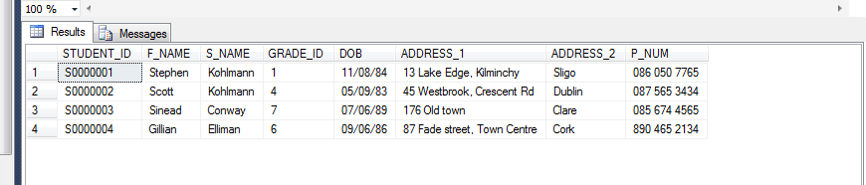
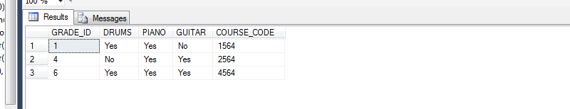
GRADE_ID 7 is a foreign key in table 1 therefore the value of 7 is allowed. Even though the GRADE_ID in table 2 is a primary key this will not be affected unless a constraint is setup between the tables.

Q10

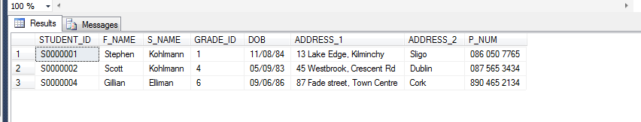
Q11

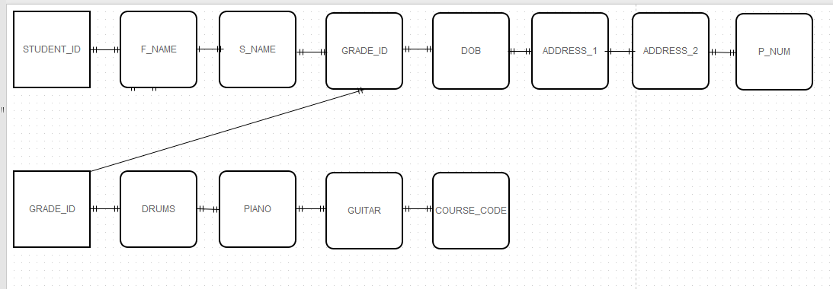
Q12

Msg 547, Level 16, State 0, Line 1
The INSERT statement conflicted with the FOREIGN KEY constraint "FK_Graded Students_Grade". The conflict occurred in database "ITSLIGO1", table "dbo.Grade", column 'GRADE_ID'.
The statement has been terminated.

Q13

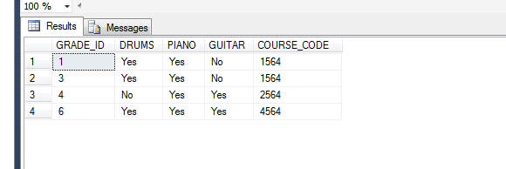

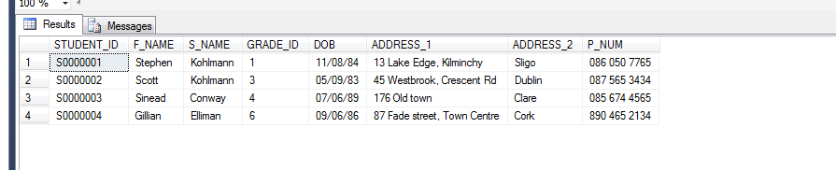
Q14

Q15
